**National Institute of Technology Surathkal Karnataka**

**Engineer – 2018**



LASER TURRET

By: rohit khoja

Mohammad iqram

ratan mamdekar

**Abstract/Aim of Project:**

The aim of project is to make a some kind of game in which there will be two side. For each side there are 24 LED's(red and blue) and score board. LED will blink randomly and as the player shoot the led or point on led with the help of laser gun , successful hit on LED will increase the score board.

**Parts Needed/Used:**

LED's

56k ohm registers and 330 ohm registers

LDR's , PCB's ,solder gun ,butter paper ,

ic,help of msp430 etc

**How it work:**

In the shown figure as shown there is one LDR , one LED ,and two registers.this is the basic circuit and in the main board there are 24 circuits same as this.

In this as the laser light emit on LDR. The registance of LDR will decrease and and voltage on 65k ohm will increase. As we are taking output on 56k ohm the higher output will increase the score board by one.

In score board first we use msp430 and write a code for randomly blinking of LED's and increase score when out put is high using shift registers and dumped the code in ic.

we use the ic to blink the LED's and to increase the count on score board.

**Steps:**

1. first we made all 24 small circuits:- in this we took PCB's and cut them in the size of circuit. In every PCB we use one LED ,2 registers,and one LDR's and then soldered them. the circuit is given in image .Then we made common ground to all the circuits using wire and separate vcc and output for all the circuits using wires. finally we stick 12 circuits (red led) and 12 circuits ( blue led) on the both side of board.
2. the ic part : in this we use msp430 to push the code in ic.we write code for randomly blinking of led ,shift registers to increase the score and score to increase when it got output higher then specific .codes are attached below.
3. finally we connect all the circuits with ic.

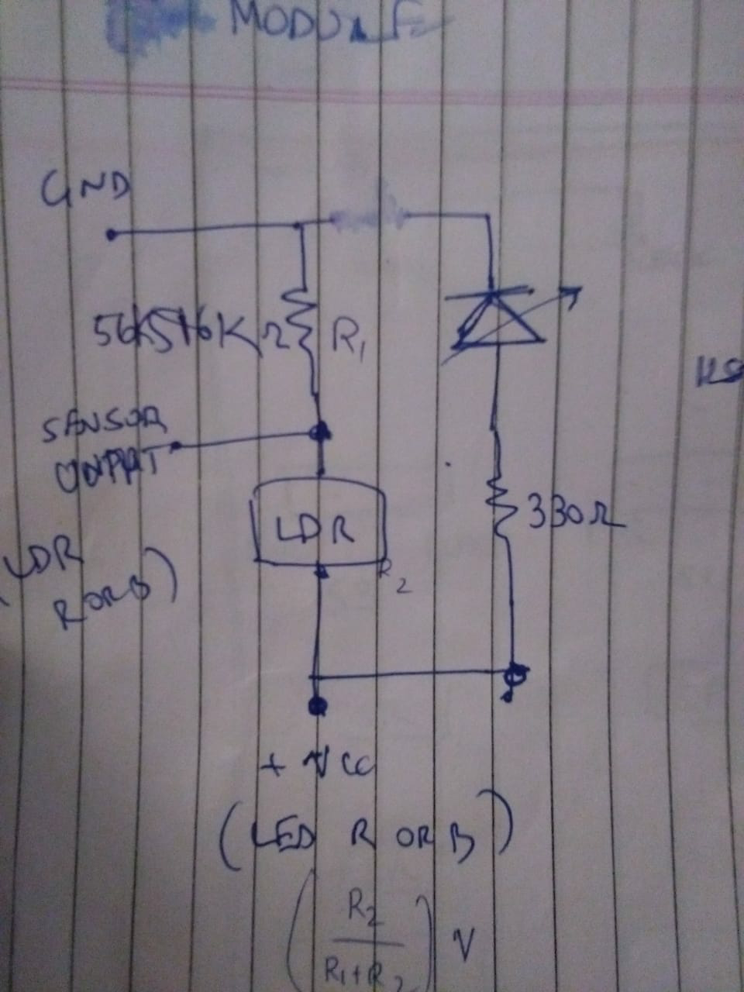

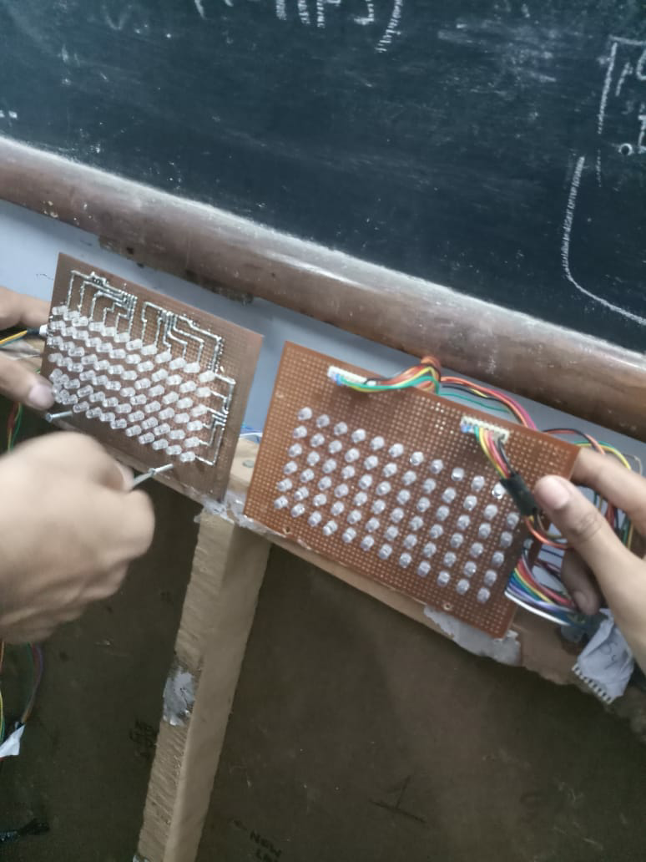

<https://drive.google.com/folderview?id=10VFqFjDi49rOWip7oXawMGHb92Kbx6x3>

1. Include links to relevant software used.
2. Include lot of pictures!!
3. Also add link to codes if any.

**Troubleshooting:**

After soldering a circuit components check with multimeter that is it properly connected or not .when connecting the wires see the pattern of wires written on back side of board.

**Problems Faced**

Our project was successful but we face just two problems.

the butter paper which we used it was reflecting the light of led and that light was able to decrease the registance of LDR and the score board was increasing the count without any pointing of gun .so we have to remove the paper.

Second was few LED's was not glowing.it might be because of their improper connection.

**Demo and Pictures**

this is link of videos

<https://drive.google.com/folderview?id=10VFqFjDi49rOWip7oXawMGHb92Kbx6x3>

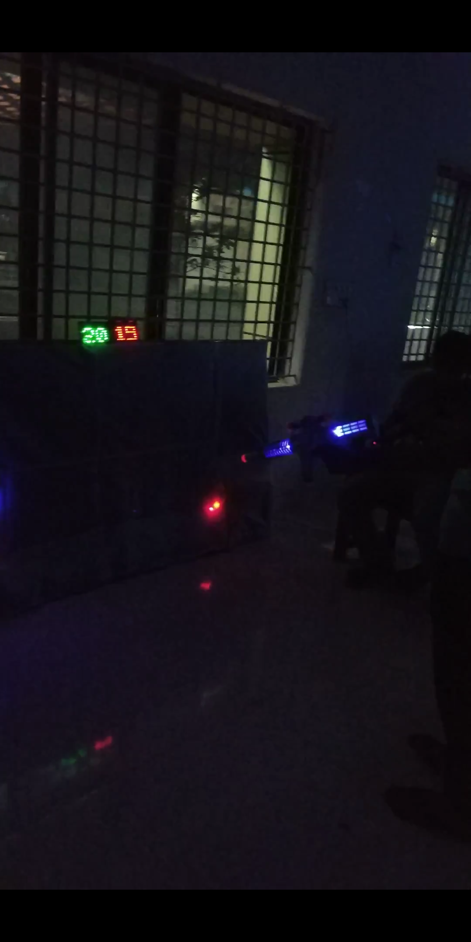

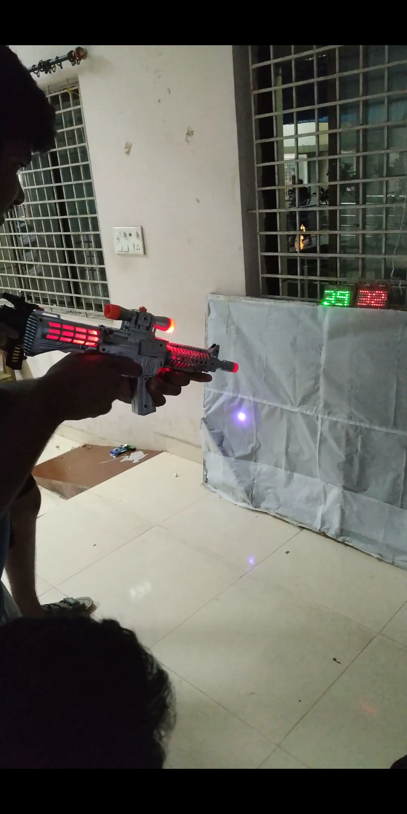

and this is link for codes

<https://drive.google.com/folderview?id=10aaJw2HUJQhoJNcPyAxxRBFU3cwl_mjv>

**Important links**

<https://drive.google.com/folderview?id=10aaJw2HUJQhoJNcPyAxxRBFU3cwl_mjv>

mail I'd

[rohit.khoja344@gmail.com](mailto:rohit.khoja344@gmail.com)

[iqramchhipa84@gmail.com](mailto:iqramchhipa84@gmail.com)